French recipes
Lycee Jean Drouant - Ecole Hôtelière de Paris

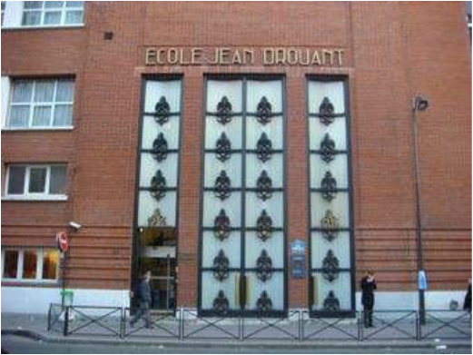

Erasmus + Y2BE
Febuary, 27th – March, 3rd 2017
Realised by the class of THR

